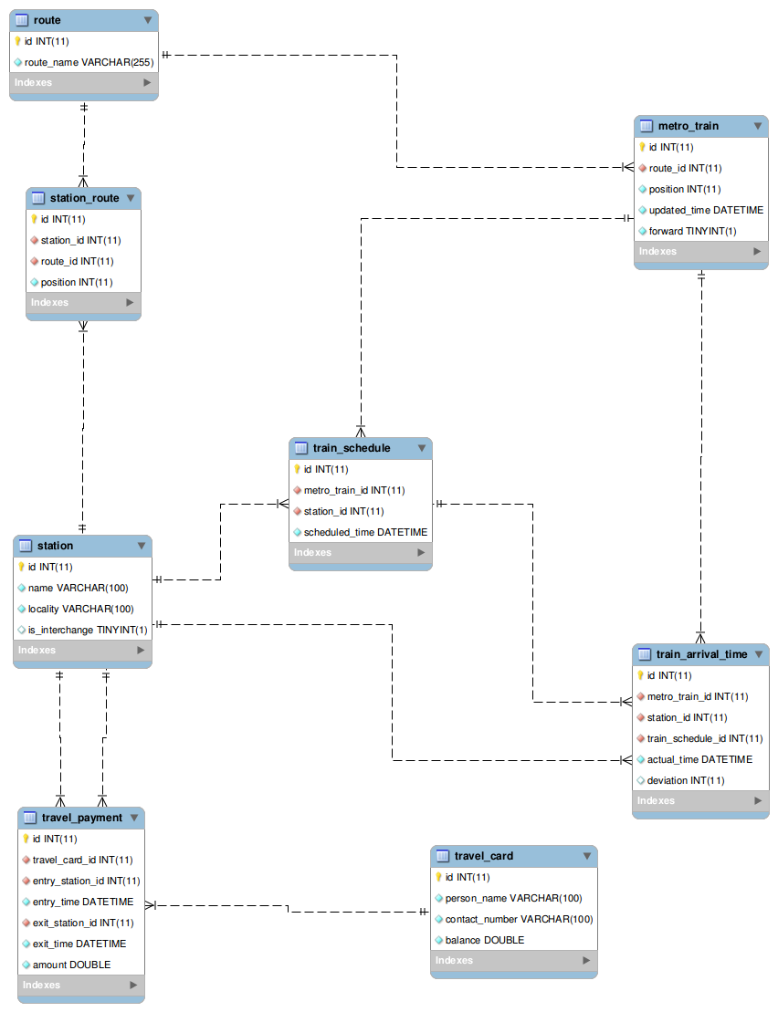

select * from route;

|  |  |
| --- | --- |
| ID | ROUTE_NAME |
| 1 | EAST WEST LINE |
| 2 | NORTH SOUTH LINE |
| 3 | NORTH EAST LINE |
| 4 | CIRCLE LINE |
| 5 | DOWNTOWN LINE |
| 6 | DOWNTOWN TOWN |

select * from station_route;

|  |  |  |  |
| --- | --- | --- | --- |
| ID | STATION_ID | ROUTE_ID | POSITION |
| 101 | 501 | 1 | 1 |
| 102 | 502 | 1 | 2 |
| 103 | 503 | 1 | 3 |
| 104 | 504 | 1 | 4 |
| 105 | 505 | 1 | 5 |
| 106 | 506 | 2 | 1 |
| 107 | 507 | 2 | 2 |
| 108 | 508 | 2 | 3 |
| 109 | 509 | 2 | 4 |
| 110 | 510 | 2 | 5 |
| 111 | 511 | 3 | 1 |
| 112 | 512 | 3 | 2 |
| 113 | 513 | 3 | 3 |
| 114 | 514 | 3 | 4 |
| 115 | 515 | 3 | 5 |
| 116 | 516 | 4 | 1 |
| 117 | 517 | 4 | 2 |
| 118 | 518 | 4 | 3 |
| 119 | 519 | 4 | 4 |
| 120 | 520 | 4 | 5 |
| 121 | 521 | 5 | 1 |
| 122 | 522 | 5 | 2 |
| 123 | 523 | 5 | 3 |
| 124 | 524 | 5 | 4 |
| 125 | 525 | 5 | 5 |

select * from metro_train;

|  |  |  |  |  |
| --- | --- | --- | --- | --- |
| ID | ROUTE_ID | POSITION | UPDATED_TIME | FORWARD |
| 1001 | 1 | 3 | 2017-12-21 09:10:20.0 | 1 |
| 1002 | 2 | 5 | 2017-12-22 14:50:15.0 | 0 |
| 1003 | 3 | 4 | 2017-12-21 09:15:15.0 | 0 |
| 1004 | 4 | 1 | 2017-12-21 09:15:15.0 | 1 |
| 1005 | 5 | 5 | 2017-12-23 10:15:25.0 | 0 |
| 1006 | 1 | 1 | 2017-12-23 21:15:15.0 | 1 |
| 1007 | 2 | 1 | 2017-12-22 09:00:15.0 | 1 |
| 1008 | 3 | 1 | 2017-12-21 10:15:15.0 | 1 |
| 1009 | 4 | 4 | 2017-12-21 09:10:15.0 | 0 |
| 1010 | 5 | 2 | 2017-12-23 22:45:15.0 | 0 |
| 1011 | 6 | 2 | 2017-12-23 22:45:15.0 | 0 |

select * from train_schedule;

|  |  |  |  |
| --- | --- | --- | --- |
| ID | METRO_TRAIN_ID | STATION_ID | SCHEDULED_TIME |
| 1 | 1001 | 505 | 2017-12-21 09:40:20.0 |
| 2 | 1002 | 506 | 2017-12-22 16:20:15.0 |
| 3 | 1003 | 511 | 2017-12-21 10:15:15.0 |
| 4 | 1004 | 520 | 2017-12-21 10:30:15.0 |
| 5 | 1005 | 521 | 2017-12-23 11:45:25.0 |
| 6 | 1006 | 525 | 2017-12-23 22:45:15.0 |
| 7 | 1007 | 510 | 2017-12-22 11:05:15.0 |
| 8 | 1008 | 515 | 2017-12-21 12:05:15.0 |
| 9 | 1009 | 516 | 2017-12-21 10:20:15.0 |
| 10 | 1010 | 521 | 2017-12-23 23:20:15.0 |

select * from station;

|  |  |  |  |
| --- | --- | --- | --- |
| ID | NAME | LOCALITY | IS_INTERCHANGE |
| 501 | PASIR RIS MRT STATION | PASIRRISDRIVE1,SINGAPORE | 0 |
| 502 | KEMBANGAN MRT STATION | 55 SIMS AVENUE EAST SINGAPORE 416551 | 0 |
| 503 | KALLANG MRT STATION | 5 SIMS AVENUE SINGAPORE 387405 | 0 |
| 504 | COMMONWEALTH MRT STATION | 375 COMMONWEALTH AVENUE SINGAPORE 149735 | 0 |
| 505 | JOO KOON MRT STATION | 91 JOO KOON CIRCLE,SINGAPORE 629116 | 0 |
| 506 | JURONG EAST MRT STATION | 10 JURONG EAST STREET 12,SINGAPORE 609690 | 1 |
| 507 | WOODLANDS MRT STATION | 30 WOODLANDS AVENUE 2 SINGAPORE 738343 | 0 |
| 508 | YIO CHU KANG MRT STATION | 3000 ANG MO KIO AVENUE 6 SINGAPORE 569813 | 0 |
| 509 | NOVENA MRT STATION | 250 THOMSON ROAD SINGAPORE 307642 | 0 |
| 510 | MARINA BAY MRT STATION | 21 PARK STREET SINGAPORE 018925 | 1 |
| 511 | HARBOURFRONT MRT STATION | 81 TELOK BLANGAH ROAD SINGAPORE 098867 | 1 |
| 512 | CHINATOWN MRT STATION | 151 NEW BRIDGE ROAD SINGAPORE 059443 | 1 |
| 513 | LITTLE INDIA MRT STATION | 60 BUKIT TIMAH ROAD SINGAPORE 229900 | 1 |
| 514 | KOVAN MRT STATION | 900 UPPER SERANGOON ROAD SINGAPORE 534799 | 0 |
| 515 | SENGKANG MRT STATION | 5 SENGKANG SQUARE SINGAPORE 545062 | 0 |
| 516 | PROMENADE MRT STATION | 2 TEMASEK AVENUE SINGAPORE 039193 | 1 |
| 517 | DAKOTA MRT STATION | 201 OLD AIRPORT ROAD SINGAPORE 397973 | 0 |
| 518 | BISHAN MRT STATION | 17 BISHAN PLACE SINGAPORE 579842 | 1 |
| 519 | LABRADOR PARK MRT STATION | 701 TELOK BLANGAH ROAD SINGAPORE 109029 | 0 |
| 520 | BUONA VISTA MRT STATION | 150 NORTH BUONA VISTA ROAD SINGAPORE 139350 | 1 |
| 521 | HILLVIEW MRT STATION | 510 UPPER BUKIT TIMAH ROAD SINGAPORE 678211 | 0 |
| 522 | FORT CANNING MRT STATION | 170 RIVER VALLEY ROAD SINGAPORE 179038 | 0 |
| 523 | GEYLANG BAHRU MRT STATION | 541 KALLANG BAHRU SINGAPORE 339355 | 0 |
| 524 | UBI MRT STATION | 51 UBI AVENUE 2 SINGAPORE 408899 | 0 |
| 525 | EXPO MRT STATION | 2 EXPO DRIVE SINGAPORE 485985 | 1 |

select * from travel_payment;

|  |  |  |  |  |  |  |
| --- | --- | --- | --- | --- | --- | --- |
| ID | TRAVEL_CARD_ID | ENTRY_STATION_ID | ENTRY_TIME | EXIT_STATION_ID | EXIT_TIME | AMOUNT |
| 1 | 656 | 503 | 2017-12-21 09:15:15.0 | 505 | 2017-12-21 09:45:15.0 | 40.25 |
| 2 | 653 | 503 | 2017-12-22 11:20:15.0 | 504 | 2017-12-22 11:45:15.0 | 29.75 |
| 3 | 654 | 501 | 2017-12-23 21:15:15.0 | 504 | 2017-12-23 21:50:15.0 | 37.25 |
| 4 | 656 | 515 | 2017-12-22 12:30:15.0 | 511 | 2017-12-22 12:55:15.0 | 36.75 |
| 5 | 659 | 516 | 2017-12-21 10:15:15.0 | 518 | 2017-12-21 11:15:15.0 | 22.25 |
| 6 | 657 | 520 | 2017-12-21 09:30:15.0 | 516 | 2017-12-21 09:43:15.0 | 45.5 |
| 7 | 660 | 521 | 2017-12-23 11:15:25.0 | 525 | 2017-12-23 11:57:25.0 | 37.45 |
| 8 | 663 | 522 | 2017-12-21 09:15:15.0 | 524 | 2017-12-21 09:30:15.0 | 39.35 |
| 9 | 660 | 506 | 2017-12-22 14:30:15.0 | 510 | 2017-12-22 15:05:15.0 | 30 |
| 10 | 653 | 512 | 2017-12-21 09:15:15.0 | 514 | 2017-12-21 09:40:15.0 | 25.75 |
| 11 | 654 | 513 | 2017-12-21 10:15:20.0 | 511 | 2017-12-21 10:40:20.0 | 32.65 |
| 12 | 655 | 507 | 2017-12-22 09:15:15.0 | 510 | 2017-12-22 09:50:15.0 | 38.25 |
| 13 | 651 | 517 | 2017-12-23 11:15:15.0 | 519 | 2017-12-23 11:40:15.0 | 19.5 |
| 14 | 658 | 525 | 2017-12-23 12:45:15.0 | 523 | 2017-12-23 13:15:20.0 | 41.25 |
| 15 | 662 | 506 | 2017-12-23 15:40:15.0 | 509 | 2017-12-23 16:00:25.0 | 25 |

select * from travel_card;

|  |  |  |  |
| --- | --- | --- | --- |
| ID | PERSON_NAME | CONTACT_NUMBER | BALANCE |
| 651 | S DHANABALAN | +65 81237452 | 25.25 |
| 652 | GERARD EE | +65 87892541 | 20 |
| 653 | ALEX | +65 95227525 | 35.21 |
| 654 | KENNY | +65 85227415 | 43.25 |
| 655 | HAN SAI POR | +65 95245255 | 45.75 |
| 656 | MICHAEL | +65 62582155 | 52.29 |
| 657 | KAM NING | +65 78245225 | 49.25 |
| 658 | BAEY YAM KENG | +65 85255255 | 46.75 |
| 659 | ALICIA | +65 92525552 | 29.25 |
| 660 | AARON LEE | +65 92588226 | 43.25 |
| 661 | LAWRENCE WONG | +65 82528552 | 32.35 |
| 662 | RISSA | +65 25252552 | 29.27 |
| 663 | JASIM | +65 86352555 | 42.5 |
| 664 | VIVIAN BALAKRISHNAN | +65 25825662 | 47.55 |
| 665 | JJ LIN | +65 25245652 | 48.35 |

select * from train_arrival_time;

|  |  |  |  |  |  |
| --- | --- | --- | --- | --- | --- |
| ID | METRO_TRAIN_ID | STATION_ID | TRAIN_SCHEDULE_ID | ACTUAL_TIME | DEVIATION |
| 1 | 1001 | 503 | 1 | 2017-12-21 09:10:20.0 | 0 |
| 2 | 1002 | 507 | 2 | 2017-12-22 15:43:15.0 | 3 |
| 3 | 1003 | 512 | 3 | 2017-12-21 09:52:15.0 | 2 |
| 4 | 1004 | 519 | 4 | 2017-12-21 10:25:15.0 | 5 |
| 5 | 1005 | 524 | 5 | 2017-12-23 10:40:25.0 | 0 |
| 6 | 1006 | 504 | 6 | 2017-12-23 22:31:15.0 | 11 |
| 7 | 1007 | 507 | 7 | 2017-12-22 09:21:15.0 | 1 |
| 8 | 1008 | 514 | 8 | 2017-12-21 11:36:15.0 | 6 |
| 9 | 1009 | 518 | 9 | 2017-12-21 09:40:15.0 | 0 |
| 10 | 1010 | 523 | 10 | 2017-12-23 22:27:15.0 | 7 |
| 11 | 1002 | 508 | 2 | 2017-12-22 15:23:15.0 | 8 |
| 12 | 1006 | 502 | 6 | 2017-12-23 21:35:15.0 | 0 |
| 13 | 1004 | 520 | 4 | 2017-12-21 10:44:15.0 | 14 |
| 14 | 1010 | 522 | 10 | 2017-12-23 23:02:15.0 | 2 |
| 15 | 1001 | 505 | 1 | 2017-12-21 09:44:20.0 | 4 |